
Centre for BioSystems Science and Engineering (BSSE) Annex Building,
Old Biochemistry Department
Indian Institute of Science

CELLINK-IISc Centre of Excellence
BSSE Annex Building,
Old Biochemistry Department, Indian Institute of Science, C V Raman Road, Bangalore-560012, Karnataka.

Slot Booking cum Charge Sheet

- Name of the User:

- Name of the Principal Investigator:

- Name of the Department:

- Name of the Institute:

- Contact no. and e-mail address:

- Sample Information: Biomaterial Printing Cell-laden Bioink Printing

- Type of Cell-line used and approx. size:

- Nozzle/Needle Size requirement:

- Type of Printhead for Extrusion-based Bioprinter:
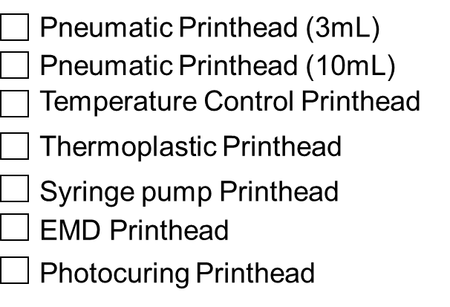
10. Cross-linking Module requirement:
11. Type of Probe for BIONOVA:
12. Choice of Bioprinter and charges per slot:

Sl. No. | Bioprinter | In-house Users | External users (Academician) | External users (Corporate)
1 | BIO X (3 Extruders)
2 | BIO X6 (6 Extruders with Co-Axial Printing)
3 | BIONOVA X
(* all charges are inclusive of 18% GST)
13. Date of Booking (Available from Monday to Fridays, except holidays):

14. Select your time slots: (Tick mark)

TIMINGS | BIO X | BIO X6 | BIONOVA
10:00 - 11:30 AM
11:30 - 01:00 PM
02:00 - 03:30 PM
03:30 - 05:00 PM

15. Remarks (if any):

For booking a slot, please write to facility in-charge Ms. Vijeta Jaiswal at vijeta.jaiswal@cellink.com
or call at +91 9880327615.

Student’s Signature: Date:

PI/HOD Signature:

Details of Bank Account for making Payment:

